**Name: Hamza Mehmood Mughal**

**Intern ID: TN/IN02/PY/009**

**Task no:** **14**

**Question: Use random and date time script.**

**Create math_utils module and import.**

**Use random and date time script:**

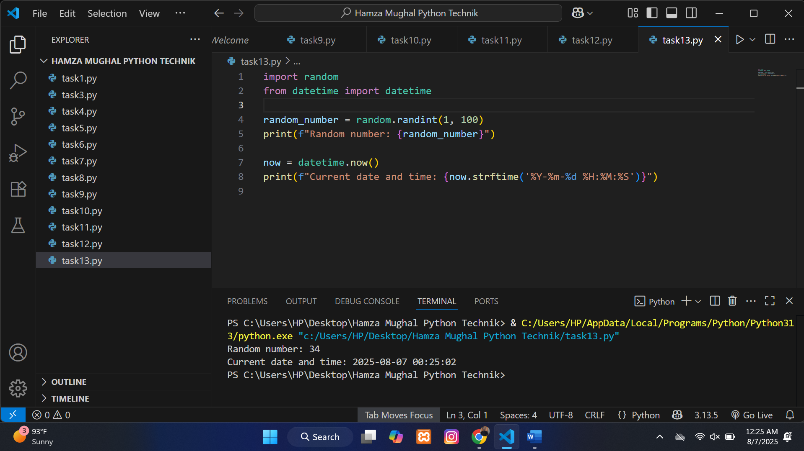

**Create math_utils module and import:**

